- SQL Tasks
- Retrieve product name and order quantity using INNER JOIN between Products and Orders.

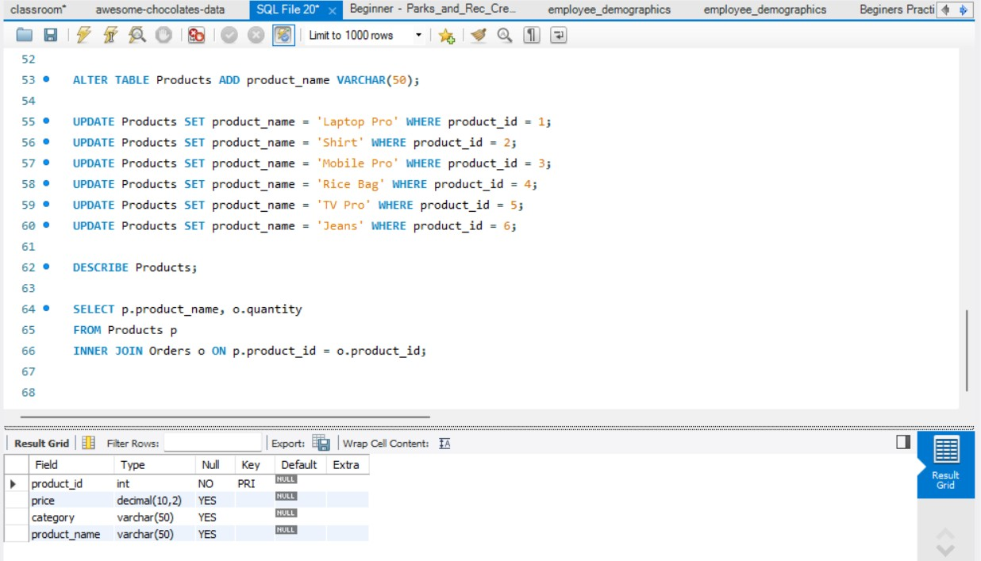

What we understood:
We understood how to combine data from two tables using INNER JOIN.

What logic is behind:
INNER JOIN matches rows from both tables where product_id is same and returns combined data.

- Retrieve products where price BETWEEN 1000 AND 5000 using JOIN.
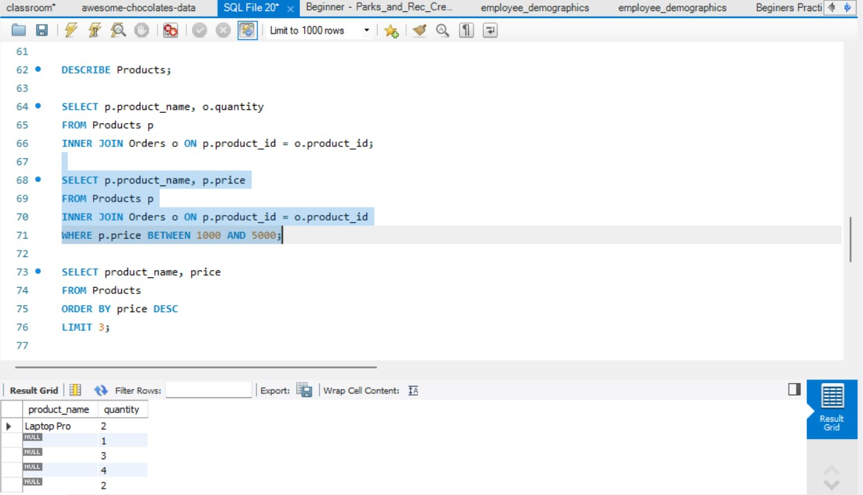
What we understood:
We learned how to filter data using a range condition.
What logic is behind:
BETWEEN checks if value lies within a range (inclusive).

- Retrieve top 3 products with highest price using LIMIT.
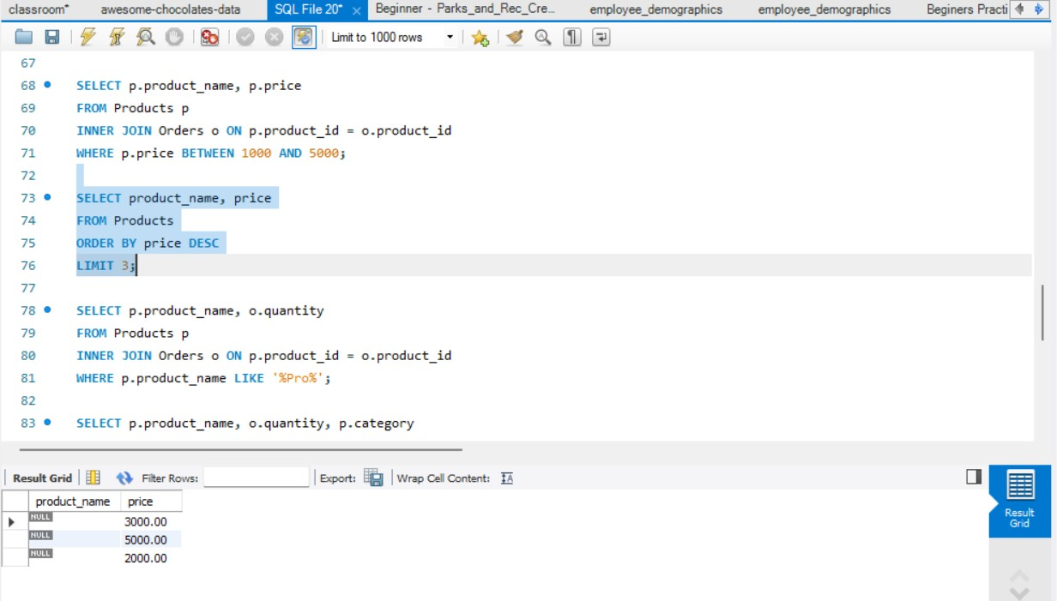

What we understood:
We learned sorting and limiting results.

What logic is behind:
Data is sorted in descending order and top 3 rows are selected

- Retrieve products where name LIKE '%Pro%' using JOIN.

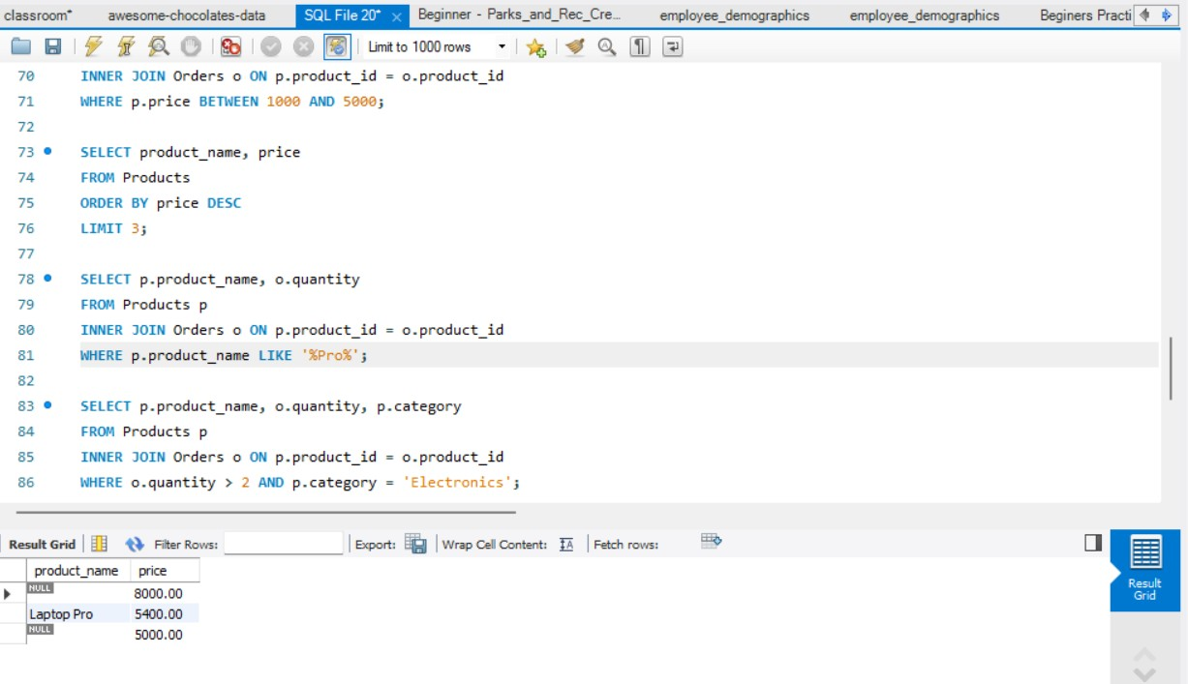

What we understood:
We learned pattern matching using LIKE.

What logic is behind:
%Pro% means any text containing “Pro”.
- Retrieve orders where quantity > 2 AND product category = 'Electronics' using JOIN.

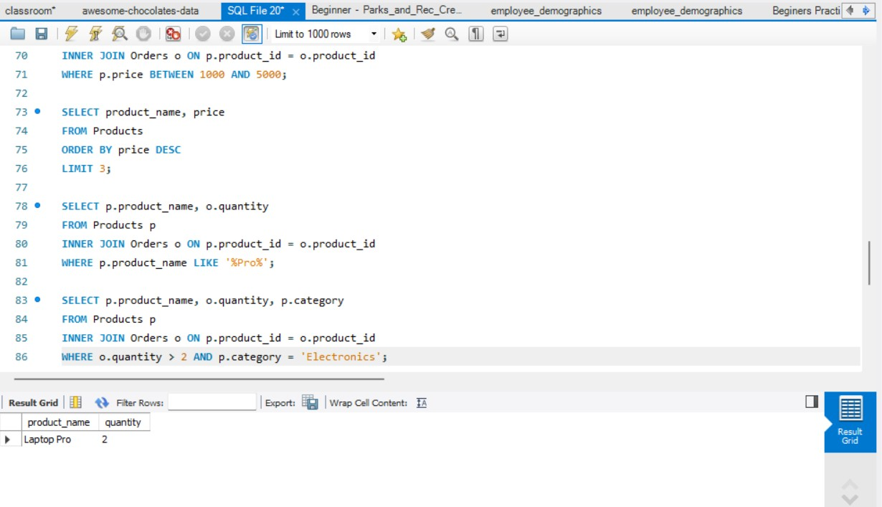

What we understood:
We learned applying multiple conditions.

What logic is behind:
AND ensures both conditions must be true.

Python Tasks

- Given a list of numbers, find the second largest element using loop.
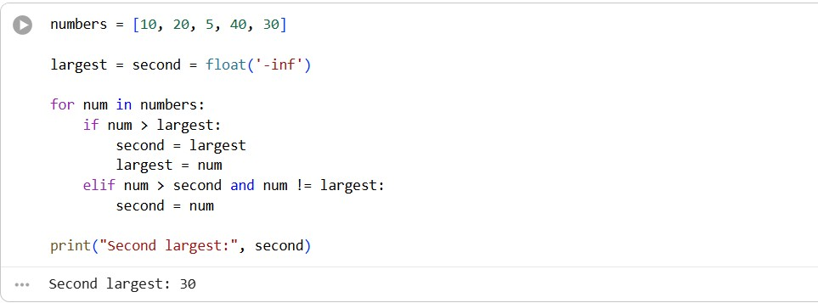

What we understood:
We learned how to track multiple values in a loop.

Logic:
We update largest and second largest step by step.

- Given a string, reverse it using while loop.
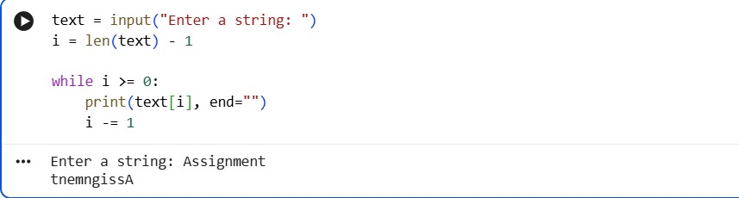

What we understood:
We learned reverse traversal.

Logic:
Start from last index and move backward.

- Given a list, count how many elements are even using loop.
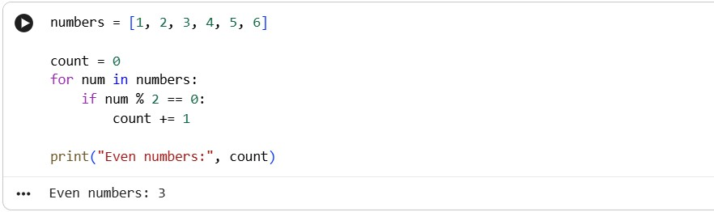
What we understood:
We learned counting using condition.
Logic:
Check divisibility by 2.

- Given a dictionary, print keys whose values are greater than 50.
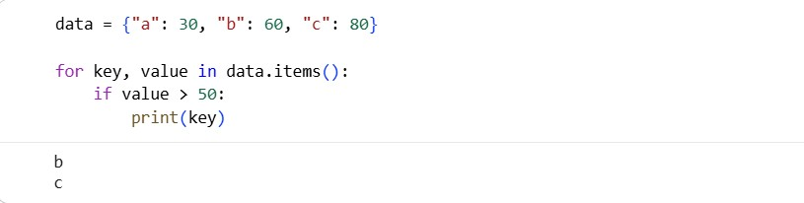

What we understood:
We learned dictionary iteration.

Logic:
Filter based on value condition.

- Given a set, print all elements greater than 10.
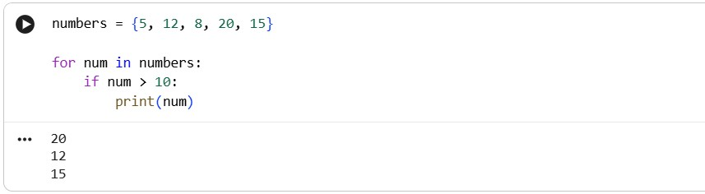

What we understood:
We learned how sets work.

Logic:
Check each element and print if condition is true

